Just mid-way through 2018 and already, research of the ever evolving media has reported changes in new media consumption and mobile behavior worth noting. With data points from both the Infinite Dial series from Edison Research and Triton Digital, and a survey fielded by the Research Moms at Edison, we learned how moms in the United States continue to “own their tech toolkit.” From Smart Speakers, Smartphones and Social Media, the insights we gleaned from this report are ones every broadcast ministry organization today needs to keep in mind for tomorrow!
Mom’s Social Networking Habits

A media trend to watch is mom and Facebook - though Facebook usage is still high for mom, there is a decrease: 84% usage in 2017 vs. 79% usage in 2018– it could be a blip for 2018 or the beginning of a downward trend.

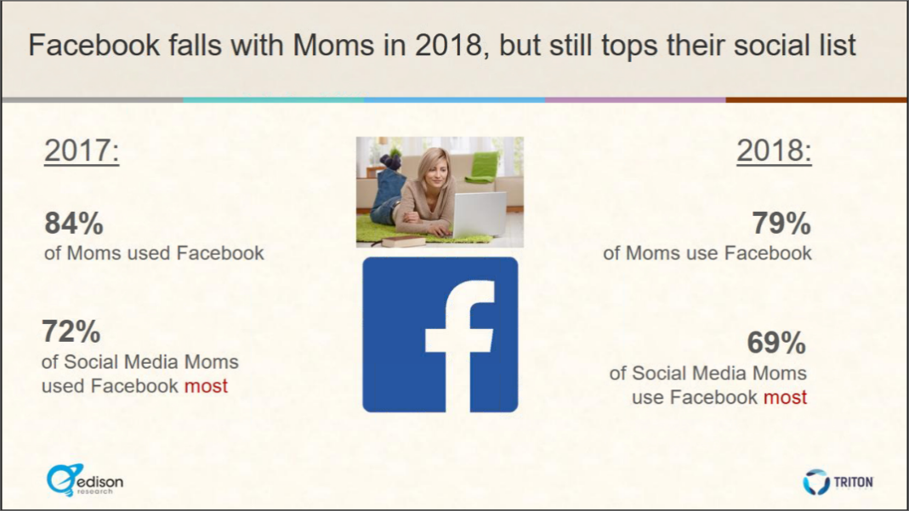
Looking across the social board, social sites that now hold their own place with moms include Pinterest with more than half of all moms visiting the platform regularly. Instagram usage among moms is also growing. In some regard a surprise and yet, not so much a surprise, is the growth of Snapchat usage among moms. I confess that I’m not on the platform because of its appeal, I’m on it daily because I’m a mom of a teenager – that’s huge incentive!

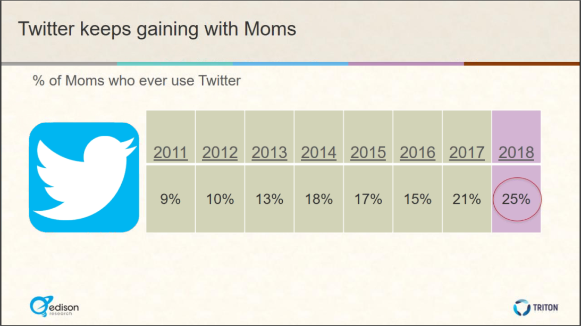
A favorite find in the report is about social platform underdog and one of my favorite platforms, Twitter. Twitter struggled to gain in early years but is now gaining momentum – a quarter of moms are now using the social media site!

What Does Mobile Mean to Mom

No shocking surprises when it comes to what mobile means for mom in 2018:

- Moms are never out of touch: 92% own smartphone.
- Less interest in tablets - moms prefer audio options when they can take it on the go!
- 98% of moms have internet access from many locations (home, work, school, etc.) – stressing the fact that internet is important for mom as most day-to-day tasks are done on line (scheduling appointments, shopping, checking kids’ grades, etc.).

Moms are Creating New Media
We moms are into creating and that ability factors into new media . . . simply because of our content usage, we remain a driving force in new media!
- Moms and their growing relationship with Podcasts.
Podcasts continue to interest moms with notable gains from 2017 -- 19% of moms have listened to podcasts alone in this last week!
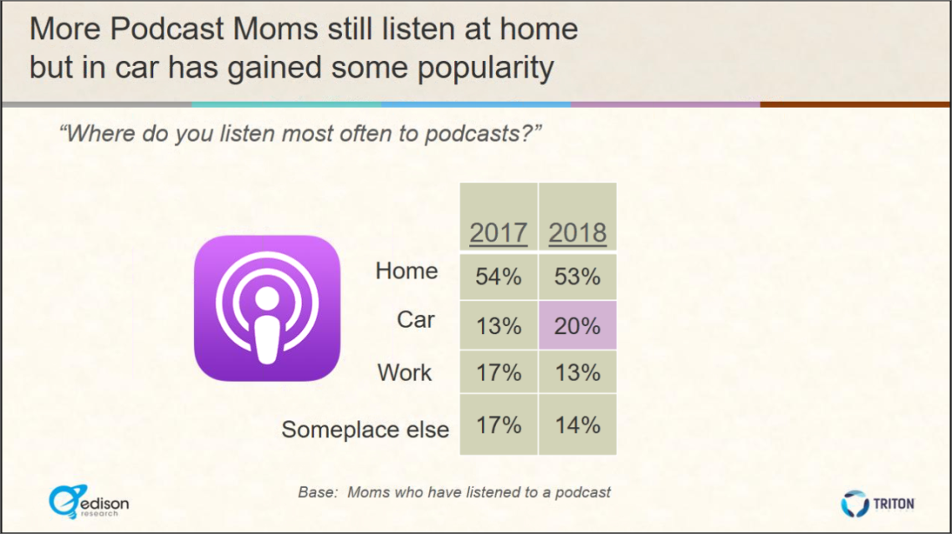
How are moms listening to podcasts? Mobile dominates over computer for Moms’ podcasts with 72% listening via smartphone, tablet or portable audio and 28% listening via computer.
More podcast moms still listen at home but in-car listening has gained some popularity jumping from 13% to 20%.
- YouTube is huge and continues to grow for Moms.
79% of moms have used YouTube specifically to watch videos or listen to music.

- In 2018, more than half of Moms subscribe to Amazon Prime.
Shipping is probably the attraction of Amazon Prime to moms, though with cost going up, we’ll see how truly “attracted” to it they are!
- Smart speakers have Mom’s attention.
82% of moms have heard of Amazon Alexa and 66% of moms have heard of Google Home. Overall, the percentage of moms who have heard of each type of smart speaker has quadrupled since last year with 23% of moms owning a smart speaker. This is a trend Edison noted they’ll continue to watch as speakers gain more and more integration.
Take note: smart speakers have the potential to be a game changer for mom!
Some things Never Change: Radio and Moms

Radio continues to play a significant role in mom’s life with 78% of moms reporting having listened to AM/FM radio in the past week.
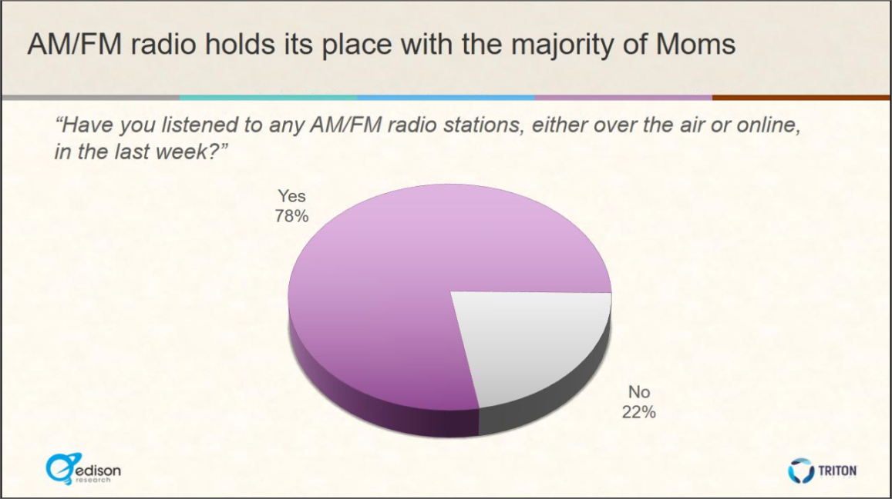

What We Learned from the Moms in the Infinite Dial 2018 Report

- Mom is never out of touch; social media engaged.
- nearly every mom has a cell phone
- Facebook still preferred over others

- Her mobile behavior won’t be stopped.
- Smartphone ownership is still rising
- Smartphone wins over tablet

- Take advantage of new media to reach Mom
- Mom is using YouTube
- Smart Speakers are finding their way

